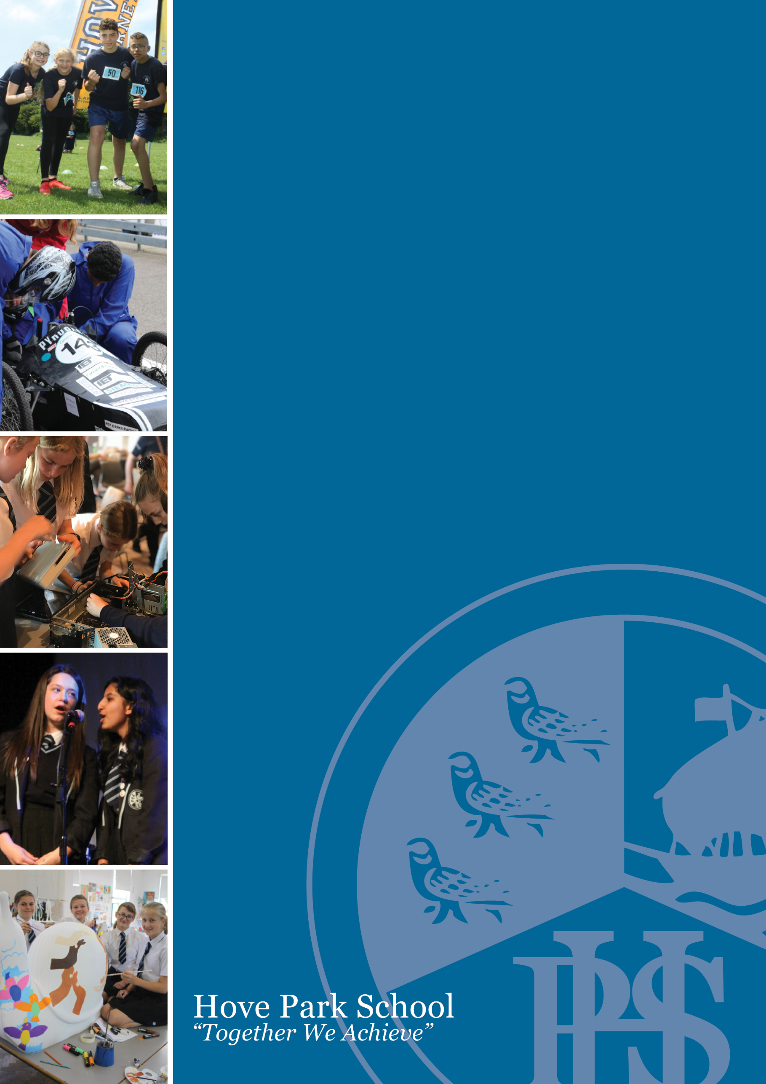
Teaching Assistant Level B – (Individual Needs Assistant – Supporting a student with visual impairment & Urdu speaker)

Information Pack

Dear Colleague,
I am delighted that you are considering joining Hove Park School and Sixth Form. At Hove Park, we believe that our school is a place where a community develops and thrives; a place where we come together to support each other to achieve. This is an exciting opportunity to join the school in improving the outcomes and wellbeing of our students. At Hove Park School, there is a strong community ethos underpinned by positive relationships. Ofsted recognised these positive influences and that we continue to be a good school when they inspected in December 2021.
Please take time to read this application pack and explore our website (www.hovepark.org.uk) to get a feel for Hove Park School and its community. If you have the passion and ambition to help the school make a difference in this role and feel you are a good fit, please consider applying.
To apply, please submit a completed support staff application form to recruitment@hovepark.org.uk. Applications for this vacancy must be received by 8:00 am on Wednesday, 21 June 2023. Please note that the school cannot accept CVs and that Hove Park School is committed to promoting the safeguarding and welfare of our students. We also expect all staff and volunteers to share this commitment.

Yours faithfully,

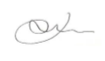

Jim Roberts
Headteacher

Post Title: Teaching Assistant Level B – (Individual Needs Assistant – Supporting a student
with visual impairment & Urdu speaker)
Salary & Grade NJC Scale 4a (SP 9-10) £17,279 – £17,596 (Actual)
Contract Type Term-time only, 47.15 paid weeks per year
Contract Term Permanent (Will also consider part time and flexible working patterns)
Contract Hours 30.4 hours per week, Monday to Friday, 8:25 am to 3:15 pm (45-minute unpaid break per day). We will also consider part time and flexible working patterns
Start Date ASAP

The SEND department at Hove Park School is looking to appoint a highly motivated, enthusiastic and committed Individual Needs Assistant to support the learning and inclusion of an Urdu speaking student with a visual impairment who is new to English.

As an experienced Teaching Assistant in this area, you will possess a commitment for inclusion, a passion for overcoming barriers to learning and a belief that through working with children and young people we can maximise their potential to lead happy, healthy and fulfilled lives. You will show initiative, good communication skills and an aptitude for supporting students with special educational needs and disabilities.

Deadline for Applications: 8:00 am on Wednesday, 21 June 2023

Interview date: Wednesday, 28 June 2023

This role does not meet the requirement for UK Visas and Immigration (UKVI) Points-based Immigration System. Successful candidates will need to evidence that they have the Right to Work in the UK.
Hove Park School is committed to safeguarding and promoting the welfare of children and young people and expects all staff and volunteers to share this commitment. The successful candidates will be subject to an enhanced DBS check.
Hove Park School celebrates diversity and welcomes applications from all areas of our community as we aim to have a staff body that is representative of our socially, culturally and ethnically diverse student population.
We are committed to the progression of the individual and therefore to support this position we will provide relevant in-house and certified training to help you develop and achieve success in this role.
We take the wellbeing of our staff seriously and offer many staff benefits such as an onsite gym, cycle to work scheme, local government pension scheme as well as other initiatives developed by our wellbeing team.

JOB DESCRIPTION

JOB TITLE: Teaching Assistant – General - Level B

SECTION: Schools

Please note; this is a National Generic Job Description. It describes the level of responsibility that you will be required to undertake. Within this role you will be required to carry out the majority of the tasks listed, and your line manager will advise you of those that are not applicable.

Text in bold font indicates the key level responsibilities for this role.

1. PURPOSE OF JOB

To work alongside teachers to support the learning and inclusion of a student with a visual impairment who is new to learning English.

To give assistance to a student with a visual impairment and EAL needs so that they can access the curriculum, participate in learning, experience a sense of achievement and develop independence in learning and other aspects of school life.

Being able to speak Urdu would be essential for this post.

- PRINCIPAL ACCOUNTABILITIES

Support for the Pupils

- Supervise and provide particular support for pupils, including those with special needs, ensuring their safety and access to learning activities
- Assist with the development and implementation of Individual Education / Behaviour Plans and Personal Care programmes
- Establish constructive relationships with pupils and interact with them according to individual needs
- Promote the inclusion and acceptance of all pupils
- Encourage pupils to interact with others and engage in activities led by the teacher
- Set challenging and demanding expectations and promote self-esteem and independence
- Provide feedback to pupils in relation to progress and achievement under guidance of the teacher

Support for the Teacher

- Create and maintain a purposeful, orderly and supportive environment in accordance with lesson plans and assist with the display of pupils' work
- Use strategies, in liaison with the teacher, to support pupils to achieve learning goals
- Assist with the planning of learning activities
- Monitor pupils' responses to learning activities and accurately record achievement/progress as directed
- Provide detailed and regular feedback to teachers on pupils' achievement, progress, problems etc
- Promote good behaviour, dealing promptly with conflict and incidents in line with established policy and encourage pupils to take responsibility for their own behaviour
- Establish constructive relationships with parents / carers
- Administer routine tests and invigilate exams and undertake routine marking of pupils' work
- Provide clerical / admin support, e.g. photocopying, typing, filing, money, administer coursework etc

Support for the Curriculum

- Undertake structured and agreed learning activities / teaching programmes, adjusting activities resources and teaching materials according to pupil responses
- Support a specific child 1:1 with tasks throughout the school day to ensure they are fully included in activities alongside their peers.
- Undertake programmes linked to local and national learning strategies e.g. literacy, numeracy, KS3, early years, recording achievement and progress and feeding back to the teacher
- Support the use of ICT in learning activities and develop pupils' competence and independence in its use
- Prepare, maintain and use equipment / resources required to meet the lesson plans/relevant learning activity and assist pupils in their use

Support for the School

- Be aware of and comply with policies and procedures relating to child protection, health, safety and security, confidentiality and data protection, reporting all concerns to an appropriate person
- Be aware of and support difference and ensure pupils have equal access to opportunities to learn and develop
- Contribute to the overall ethos / work / aims of the school
- Appreciate and support the role of other professionals
- Attend and participate in relevant meetings as required
- Participate in training and other learning activities and performance development as required
- Assist with the supervision of pupils out of lesson times, including before and after school and at lunchtime
- Accompany teaching staff and pupils on visits, trips and out of school activities as required and take responsibility for a group under the supervision of the teacher

The list of duties in the job description should not be regarded as exclusive or exhaustive. There will be other duties and requirements associated with your job and, in addition, as a term of your employment you may be required to undertake various other duties as may reasonably be required.

Your duties will be as set out in the above job description but please note that the Council reserves the right to update your job description, from time to time, to reflect changes in, or to, your job.

You will be consulted about any proposed changes.

PERSON SPECIFICATION

POST TITLE: Teaching Assistant – INA - Level B

CRITERIA | ESSENTIAL CRITERIA
Job Related Education and Qualifications  and Knowledge | - Completion of DfES Teacher Assistant Induction Programme  - NVQ 2 for Teaching Assistants or equivalent qualification or experience  - Understanding of relevant policies / codes of practice and awareness of relevant legislation  - General understanding of national / foundation stage curriculum and other basic learning programmes / strategies  - Basic understanding of child development and learning  - Training in the relevant learning strategies e.g. literacy  - First aid training as appropriate
Experience | - Experience of working with or caring for children of relevant age  - Experience in the effective use of ICT to support learning
Skills/Abilities | - Good numeracy / literacy skills  - Able to speak and write Urdu  - Ability to relate to children and adults  - Ability to use other equipment technology - video, photocopier  - Ability to self-evaluate learning needs and actively seek learning opportunities  - Work constructively as part of a team, understanding classroom roles and responsibilities and your own position within these
Equalities | - To be able to demonstrate a commitment to the principles of Equalities and to be able to carry out duties in accordance with the Council’s Equalities Policy.

Our Values and Ethos at Hove Park School and Sixth Form

A school is more than just a place where students come to learn. It is also a place where a community develops and thrives. It is a place where we come together to support each other achieve whether it is in the classroom learning, on the sports field competing or on the stage performing, we know that success comes from us all working together. Student progress will always remain a key priority because outcomes so often dictate future pathways and opportunities for young people. Having been again judged by Ofsted as a ‘good’ school, we continue to reflect on the structures and routines that we expect to see in every lesson. Exploring the ways we teach to ensure we drive improvement and our ambition to be ‘outstanding’ at the next inspection. Our early adoption of a digital device for every child has provided significant opportunities to innovate and explore digital pedagogy - both at Hove Park but also within our community and beyond. Our Wellbeing at School award demonstrates an ethos focused on ensuring all students feel cared for and supported throughout their time with us. Our curriculum has been planned and developed to provide a whole education for all students. When we describe our curriculum we are not just talking about the sequencing of lessons and subjects across the Key Stages but also the half-termly curriculum enrichment days and extra-curricular provision that together enrich and broaden a student’s time at Hove Park. A learning journey that provides a traditional foundation at Key Stage 3 from which students can build on individual strengths. We are ambitious for all our students and expect them, where appropriate to retain a breadth to their studies through the study of EBACC subjects and the use of our Project days. The final part of my vision for our school relates very much about the school experience each and every student will have. It is about identifying the skills, values and attributes that we believe students should develop during their time with us and the things they will see, hear, try and explore at KS3, KS4 and KS5. It is an exciting time to be part of Hove Park School as we continue to shape our future and the way we support all students to grow and achieve

