HR Advisor – Policy and Projects
1

Salary £22,183 - £24,491
Generous benefits package

Welcome message from Alison McManamon
Assistant Director Human Resources & Organisational Development

Thank you for your interest in this role
Brighton & Hove is a great place to live, learn and work. Our diverse and vibrant community is passionate about our city and there’s a shared commitment to celebrating and promoting all that makes Brighton & Hove so unique.
Its success however, in common with all cities in the country, masks considerable and significant issues related to poverty, inequality and fairness for many of its residents. This is also against a backdrop of huge reductions in local government funding, rising demand for our services, and the impact of COVID-19 and uncertainty in the world.
Working for Brighton & Hove City Council means you’ll also be joining an organisation that’s active in the community and developing its transformative journey so we can continue to do the best for the city.
We’re committed to continuous modernisation ensuring our services evolve, improve, innovate, and offer an excellent customer experience and great value for money. Our commitment to our people during this time at change makes this a really exciting time to join the HROD team. We take our responsibility as an employer seriously, and HR has a central role, with an established place on the executive leadership team.
Working in HROD at Brighton & Hove is exciting, at times challenging and always interesting. In an environment with complex politics and industrial relations, the contribution of the service is valued, and as a talented HR professional you will have lots of chance to make a difference.
In 2018 we adopted Our People Promise – an enhanced employer offer for our employees, with five commitments outlining what we offer our staff. Demonstrating how you will help the council keep its promise every day will be crucial.
In return for your services, we offer a friendly and welcoming place to work, with a competitive salary and benefits package, and a team of talented staff who all care deeply about the city they serve. If you believe that you have the drive, skills and experience
to contribute and influence at the top level in our organisation, I would be delighted to receive your application.

19

Council leadership and organisation:
Operationally the council is organised into six directorates, commissioning and delivering around 700 services. Our business support services are delivered jointly with East Sussex County Council and Surrey County Council through the innovative Orbis Partnership.
The directorates are:

Economy, Environment & Culture
  - Families, Children & Learning
  - Finance & Resources (services provided through the Orbis Partnership)
  - Health & Adult Social Care
  - Housing, Neighbourhoods & Communities
  - Strategy, Governance & Law

The day-to-day leadership and management of council operations, such as managing council resources, commissioning and providing services, are delegated to the Executive Leadership Team.
The team is formed from each directorate lead and the Chief Executive Officer, with other council officers or partners invited to attend when needed.
They meet weekly and work closely with stakeholders to ensure good corporate governance, develop corporate strategies, and implement the council’s policies and priorities.

Brighton & Hove City Council Structure

Chief Executive Officer
Executive Lead for
Strategy, Governance & Law
Executive Director
Housing, Neighbourhoods, & Communities
Executive Director
Health & Adult Social Care
Executive Director
Finance & Resources (ORBIS lead)
Executive Director
Families,
Children
& Learning
Executive Director
Economy, Environment & Culture

Assistant Director City
Environment
Assistant Director Education & Skills
Deputy Chief Finance Officer
Assistant Director Commissioning
Head of Libraries
Head of Democratic Services
Assistant Director City Transport
Assistant Director Health, SEN & Disability
Head of HR & Organisational Development
Assistant Director Operations & Transformation
Head of Safer Communities
Head of Legal Services
Assistant Director Culture, Tourism & Sport
Head of Safeguarding & Performance
Head of Strategy and Engagement - IT & Digital
Director of Public Health
Assistant Director Housing
Head of Life Events and Electoral Services
Assistant Director Property & Design
Head of Performance, Improvement & Programmes
Head of Policy,
Partnerships & Scrutiny
Assistant Director City
Development & Regeneration
Assistant Director Children’s Safeguarding & Care
Head of Business Operations
Assistant Director Resources, Safeguarding & Performance
Head of Communities, Equality & Third Sector
Head of Communications

Head of Revenues & Benefits
Head of Procurement
Principal Audit Manager

The role of HR Advisor – Policy and Projects

As HR Advisor – Policy and Projects, you will join a diverse and talented team responsible for ensuring that our customers have access to leading edge HR policies and guidance tools, and for the successful delivery of HR projects as well as providing critical business support to HR.
This role is based within our existing Reward & Policy team but with a remit that will mean working with colleagues, across the HROD function and beyond.
HR Strategy Team

This role sits within the wider HR Strategy Team in HR.

The HR Strategy team will take a lead in ensuring the HR service meets the needs of the organisation in the future, providing specialist expertise to ensure appropriate reward, policy and procedural frameworks are in place. The team will lead on key strategic aspirations and on ensuring Our People Promise work-streams are aligned to corporate and directorate plans.
Our Business Partners will work with directorates, and commission the work of HR to provide seamless and joined up support in meeting the specific needs of the organisation. Business Partners will also support with corporate project work and lead on key workstreams of Our People Promise.

All roles in the team will work flexibly according to the needs of the service.

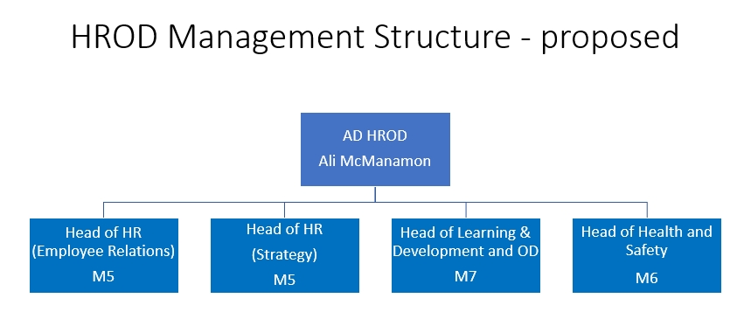
HR&OD Management Structure

HR Strategy Team Structure

