Receptionist / Administration Assistant
CENTRAL HUB BRIGHTON

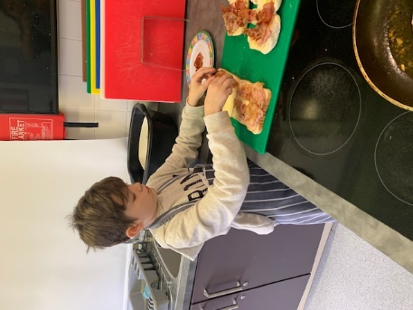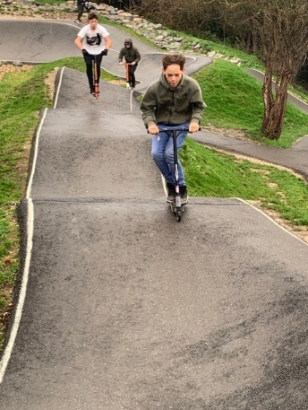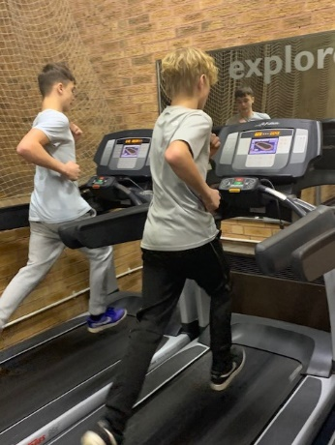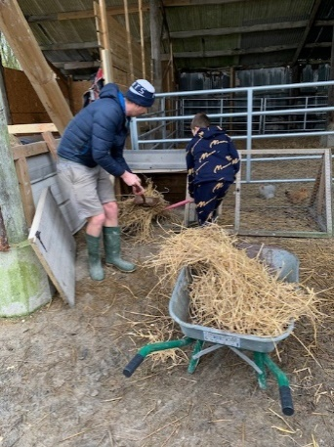

“A different kind of learning”
Our vision is to become a holistic hub where children are nurtured, inspired and engaged so that they can achieve to the best of their ability and lead happy and fulfilled lives.

Central Hub Brighton

Post: Receptionist / Administration Assistant
Salary - Level B - £19,312 - £19,698 pro rata
Hours – 30 hours per week
Contract – Fixed term for one year in the first instance

The successful applicant will have excellent organisational skills, resilience and flexibility. This position is part of a team dedicated to supporting young people with Social, Emotional and Mental Health conditions to overcome their barriers to learning.
You will need to be:
- Friendly and confident with high levels of resilience
- Able to work in a challenging environment
- Flexible and able to prioritise
- Work well as part of a team
- Work over multiple sites as required
Please express your interest on line via the Brighton and Hove City Council Website or directly to karenprout@chb.org.uk

Central Hub Brighton is the SEMH specialist provision for the city consisting of Brighton and Hove Pupil Referral unit, The Connected Hub and Homewood College and has four bases across the city. We have good links with other educational organisations in the city. We have an enthusiastic staff team and strive always to ensure our learners have access to the best possible educational experience in order that our students can overcome any barriers they have had to learning in the past. The Central Hub is committed to safeguarding and promoting the welfare of children and young people and to equality of opportunity. We expect all staff and volunteers to share this commitment. Please note that this post is exempt from the Rehabilitation of Offenders Act 1974, and is subject to a Disclosure & Barring Service (DBS) Check. BHPRU are committed to the principles of Equality and carry out duties in accordance with the Council’s Inclusive Council Policy. For any other details please contact Karen Prout – Tel: 01273 916595, Email: karenprout@chb.org.uk
Closing date for applications: 31st October 2021
Interview: w/c 1st November 2021

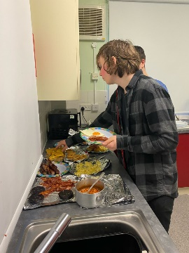
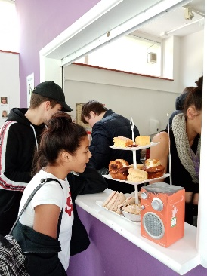

Important Information

School Visits
We warmly welcome potential applicants to visit the school. We would ask that you keep to our Covid requirements. To arrange a visit please contact a member of our school office team on 01273 916595 or email sarahparks@chb.org.uk

Closing dates for applications – 31st October 2021

Please return your completed application form to: karenprout@chb.org.uk

We are unable to accept applications via post or CVs.

Shortlisting of candidates and interviews

Emailed letters will be sent to shortlisted candidates and your referees will then be sent a reference request. Interview date will be week commencing 1st November 2021.

Salary and hours

The working pattern will be 8.30am – 3pm; Scale 3, £19,312 - £19,698 pro rata

Safeguarding

The governing body and Management Committee are committed to safeguarding and promoting the welfare of children and young people. In order to ensure this, our recruitment and selection policy is in accordance with both local and national guidance.

