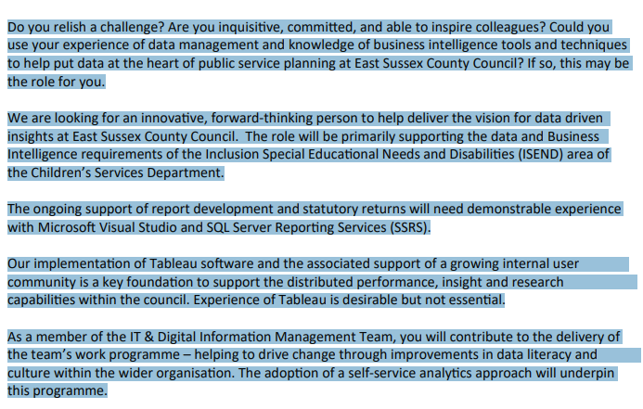

Do you enjoy working with data? Are you inquisitive, committed, and able to inspire colleagues? Could you use your experience in data management and knowledge of business intelligence tools to help put data at the heart of the public service planning at East Sussex County Council. If so, this may be the role for you.

We are looking for an innovative, forward-thinking person to deliver data driven insights. You will be primarily working with the Inclusion, Special Educational Needs and Disabilities (ISEND) area of the Children’s Services Department. The role provides ongoing support of report development and statutory returns and requires demonstratable experience with Microsoft Visual Studio and SQL Server Reporting Services (SSRS).

The implementation of business intelligence tools within the authority is a key foundation to support our data insight and research capabilities. Experience of Tableau and or Power BI is desirable, but not essential.

As a member of the IT and Digital Information Management Team, you will contribute to the delivery of the team’s work programme. You will be helping to drive change through improvements in the data literacy culture throughout the authority.

