**Head of Parks & Leisure Candidate Pack **

Thank you for your interest in applying for Brighton and Hove City Council’s Head of Parks & Leisure.

The role is based within the Culture and Environment service of the City Operations directorate.

The Head of Parks & Leisure is a critical role for the council. In this role you will be the council’s strategic and operational lead for the development and delivery of effective parks, green spaces, cemeteries/crematorium, sport and leisure facilities in the city.

**The** **Culture and Environment service**

As a member of the senior management team in the Culture and Environment service, the Head of Parks & Leisure plays a crucial role in the Council Plan mission to develop Brighton & Hove as a place where people want to live, work and learn, for all our diverse communities. The service is on a journey of modernisation to ensure residents and visitors in the city are able to access parks and leisure facilities that are fit for the future and are part of developing and improving them, and that Brighton and Hove remains a destination of choice, with positive impacts for health and wellbeing and an environmental offer that is fit for the UK’s only UNESCO Urban Biosphere and our Living Coast.

**The role of Head of Parks & Leisure**

As the Head of Parks & Leisure you will lead a diverse team of skilled, technical operational staff based across the city, ensuring an inclusive environment for all places of work. Watch [the video showing Rangers at work](https://youtu.be/-s2ewy77xCQ) to hear directly about a team working in this service area, what it’s like to work for the council, and what they love about their job.

Although based in the Culture and Environment service, your influence will extend across the council, ensuring outcomes that provide value for money and meet priorities within the Corporate Plan. A key aspect of the role is working collaboratively and in an integrated way across services, building the space for innovation and co-design and ensuring we meet the objectives of being a Learning Organisation.

This role has been designated a politically restricted post. This means that political activity is restricted through the Local Government and Housing Act 1989 and prevents post holders from taking part in certain political activities outside of work.

**The Council**

The council was formed as a unitary authority in 1997.

We are currently governed through a Leader and Cabinet model, having moved from a committee system in May 2024. Until the local elections in May 2023 where Labour achieved a majority, the council was led by various minority administrations since 2003.

The 54 councillors representing 23 wards in the city are made up of:

* 37 from the Labour Group
* 8 from the Green Group
* 5 from the Conservative Group
* 2 from the Brighton & Hove Independents
* 2 Independents (not belonging to any political group)

Councillor Bella Sankey is the Labour Leader of Brighton & Hove City Council.

You can find more information about the current political makeup of the Council and our governance system by visiting our [‘Council and democracy’](https://www.brighton-hove.gov.uk/council-and-democracy/councillors-and-committees) webpages.

**Our Leadership and Organisation**

Working for Brighton & Hove City Council means you will join one of the largest employers in Sussex and an organisation that’s active in its community. For us, a better Brighton and Hove is:

* A city to be proud of
* A fair and inclusive city
* A healthy city where people thrive, with
* A responsive council with well-run services

Operationally the council is organised into directorates, commissioning and delivering hundreds of services:

1. City Operations
2. Families, Children and Wellbeing
3. Homes and Adult Social Care
4. Central Hub

The Corporate Leadership Team meet weekly and work collaboratively with officers across the council to ensure good governance, performance management and strategy development. The [Corporate Leadership Plan](https://www.brighton-hove.gov.uk/council-and-democracy-draft/corporate-leadership-plan) details the actions being delivered across our directorates to meet our [Council Plan](https://www.brighton-hove.gov.uk/brighton-hove-city-council-plan-2023-2027) priorities.

The council has recently implemented its new structure following consultation on organisational redesign with the aim to align the structure with our overarching mission to create ‘a better Brighton & Hove for all’. The new structure will be launched in January 2025.

**Leadership Network**

In this role you will be an active member of the council’s Leadership Network. The Network consists of the top 100+ senior managers in the council, including the Chief Executive, directors, assistant directors and heads of service.

This council-wide network contributes to the development of organisational strategies that support the council’s overall strategic vision and corporate priorities, collaborates on cross-cutting work, strengthens leadership capability and capacity, and provides support and challenge to each other.

**City Operations directorate**

The City Operations directorate **vision** is for the city to be a vibrant place where people want to live, visit and do business, and where the natural environment and unique character of Brighton & Hove is protected and improved.

Our **mission** is to support sustainable economic growth and deliver reliable services that make the city an attractive, connected, well-run place for our diverse communities, businesses, and visitors.

The directorate structure:

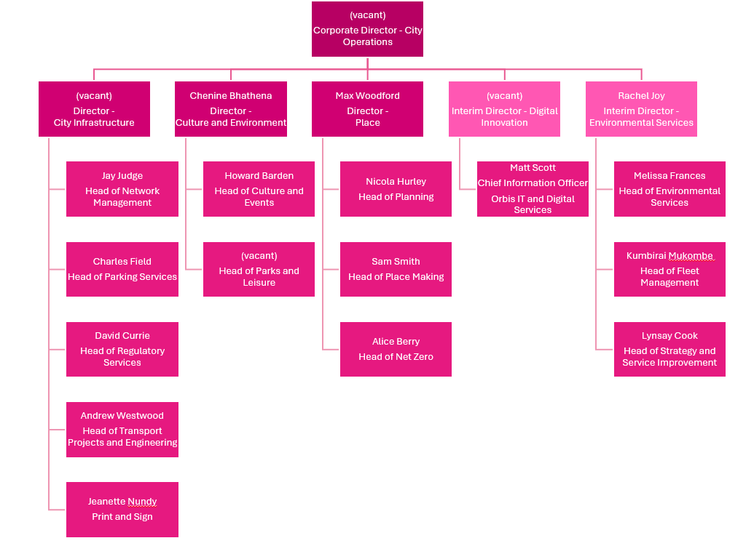

**Recruitment process and indicative timetable**

This guidance contains important information to help with your application:

* Please apply by submitting a CV and answering the shortlisting questions; ensure that you consider the values and behaviours that you bring to your leadership, and how you will transfer your skills and experience into this role when answering.
* Please ensure your full employment history is outlined in your CV; and that where there are essential criteria, competencies and/or qualifications you make clear how you meet these. We may wish to verify this information during the recruitment process.
* Please return your application by the closing date – no applications will be accepted once the long listing process has begun.
* Following shortlisting, you will be contacted to update you on the status of your application.

The following timetable sets out the key dates in the recruitment process:

|  |  |
| --- | --- |
| **Date** | **Activity** |
| 17 February 2025 | Closing date |
| w/c 17 February 2025 | Shortlisting |
| 3 or 4 March 2025 | Interview |

Dates are still being finalised and may change. Prospective candidates will be kept updated through the recruitment process.

For further information or discussion about the role, please contact Chenine Bhathena, Director Culture and Environment [Chenine.Bhathena@brighton-hove.gov.uk](mailto:Chenine.Bhathena@brighton-hove.gov.uk)