 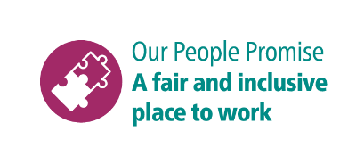

**Shortlisting questions for Project Manager**

As part of your application, you will need to provide answers to some shortlisting questions.

Your answers to the shortlisting questions are the most important part of your application as they will be used in the shortlisting process to assess whether you meet the essential requirements for the role that are set out in the person specification and to decide whether you should be offered an interview.

Before you start your application, please read our guidance on [completing the application form](https://www.brighton-hove.gov.uk/jobs/council-jobs/application-form-guidance) and [on answering shortlisting questions](https://www.brighton-hove.gov.uk/jobs/council-jobs/shortlisting-questions-guidance) as these give important advice which will increase your chance of success in the shortlisting process.

These are the questions you will be asked for this role. Please type or paste your answers to them in the boxes that will appear as you go through the online application.

1. Can you provide an example of how you have managed multiple projects, with competing deadlines and ensured progress stayed on track, milestones were met and the objectives realised.
2. Please can you provide an example of how you have set-up and implemented new working processes in an organisation and the identified benefits of this change.
3. Please provide an example of a procurement project you have completed, being clear on your role, the aims, key milestones completed and the end outcome.
4. Can you give an example where project uncertainty created risks or issues to delivery expectations and what action you took to resolve this
5. Can you provide an example of how you have secured stakeholder buy-in for your project, including recommendations made and how you managed stakeholder relationships.