 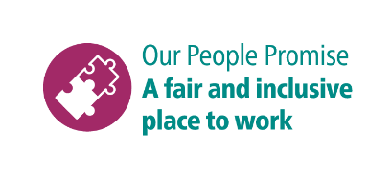

**Shortlisting questions**

As part of your application, you will need to provide answers to some shortlisting questions.

Your answers to the shortlisting questions are the most important part of your application as they will be used in the shortlisting process to assess whether you meet the essential requirements for the role that are set out in the person specification and to decide whether you should be offered an interview.

Before you start your application, please read our guidance on [completing the application form](https://www.brighton-hove.gov.uk/jobs/council-jobs/application-form-guidance) and [on answering shortlisting questions](https://www.brighton-hove.gov.uk/jobs/council-jobs/shortlisting-questions-guidance) as these give important advice which will increase your chance of success in the shortlisting process.

These are the questions you will be asked for this role. Please type or paste your answers to them in the boxes that will appear as you go through the online application.

1. Please tell us about your cleaning work experience/cleaning practices e.g. mopping, sweeping, litter-picking etc.

2. Please tell us what cleaning equipment, or cleaning tools you have used e.g. carpet cleaners, floor buffers.

3. Please tell us about a time you have noticed something which could pose a risk to others. And what did action did you do take to ensure safety?

4. Please tell us about your experience of working with other people and what is important when working as part of a team.

5. What experience do you have of managing challenging and demanding situations? From your experience what is important when evaluating situations and making decisions in pressurised situations.