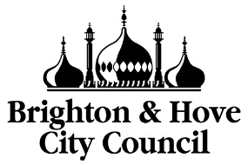 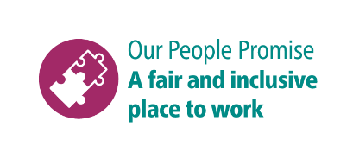

**Shortlisting questions for Damp and Mould Technician**

As part of your application, you will need to provide answers to some shortlisting questions.

Your answers to the shortlisting questions are the most important part of your application as they will be used in the shortlisting process to assess whether you meet the essential requirements for the role that are set out in the person specification and to decide whether you should be offered an interview.

Before you start your application, please read our guidance on [completing the application form](https://www.brighton-hove.gov.uk/jobs/council-jobs/application-form-guidance) and [on answering shortlisting questions](https://www.brighton-hove.gov.uk/jobs/council-jobs/shortlisting-questions-guidance) as these give important advice which will increase your chance of success in the shortlisting process.

These are the questions you will be asked for this role. Please type or paste your answers to them in the boxes that will appear as you go through the online application.

1. Do you have a full, clean driving licence?
2. Looking at the job description what do you think will be most challenging and how would you overcome this?
3. Can you describe a time when you had to analyse a situation or set of data to make a decision or solve a problem? What steps did you take, and what was the outcome?
4. Do you feel confident in your ability to carry out physical tasks such as treating and washing down mould. Please provide details of any experience you might have or that of similar tasks.