 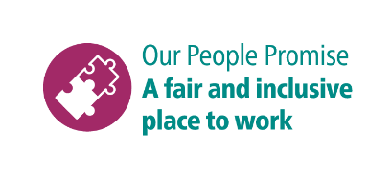

**Shortlisting questions for Plasterer**

As part of your application, you will need to provide answers to some shortlisting questions.

Your answers to the shortlisting questions are the most important part of your application as they will be used in the shortlisting process to assess whether you meet the essential requirements for the role that are set out in the person specification and to decide whether you should be offered an interview.

Before you start your application, please read our guidance on [completing the application form](https://www.brighton-hove.gov.uk/jobs/council-jobs/application-form-guidance) and [on answering shortlisting questions](https://www.brighton-hove.gov.uk/jobs/council-jobs/shortlisting-questions-guidance) as these give important advice which will increase your chance of success in the shortlisting process.

These are the questions you will be asked for this role. Please type or paste your answers to them in the boxes that will appear as you go through the online application.

1. What plastering qualifications and experience do you have?
2. Do you have a full clean driving license?
3. Please give an example of a time when you have gone above and beyond to provide excellent service to a customer
4. Are you willing to undertake training to allow you to carry out small, non-licensed asbestos removal works in a controlled and safe manner?