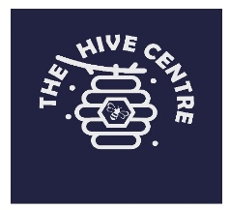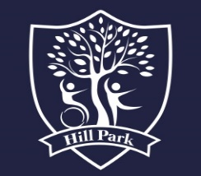Telephone: 01273 422855

Option 1: Secondary

Option 2: Primary

Option 3: The Hive

Full time English Teacher role

Key Stage 3/4 English up to Functional Skills & GCSE’s level

Hill Park School (The Hive Centre)

Lynchet Close

Hollingdean

Brighton

BN1 7FP

**Full time English Teacher**

**Key Stage 3/4** **English up to Functional Skills & GCSE’s level**

**TMS/UPS+1 SEN Allowance**

**Start date – A.S.A.P**

The Hive Centre is the third site of Hill Park School. It is a provision for Secondary aged autistic students who have high anxiety, which prevents them accessing onsite provisions such as mainstream secondary schools or facilities co-located at mainstream secondary schools.

Many will have been home educated or accessed tutoring packages and need bespoke transition to a full time onsite model. Students at The Hive will be able to access an age related curriculum and achieve GCSE’s and other Secondary accreditations.

We are looking to recruit a full time English teacher for Key Stage 3/4, with the ability to teach Functional Skills and GCSE’s.

The Hive Centre would be a great place for you to work if you:

* are reflective, flexible and resilient and enjoy working on your practice
* are interested in individualised learning with a holistic perspective that encompasses physical, sensory and behaviour development as well as curriculum learning
* have experience of teaching students working at GCSE level
* have SEND and/or specialist school experience
* are able to work in a less formal model of Secondary education

We encourage interested candidates to visit The Hive, so please contact the school office to arrange an informal visit/ conversation with the Head of Site Linda Williams.

We take safeguarding and child protection seriously and all posts at Hill Park School are subject to a satisfactory Enhanced Disclosure and Barring Certificate.

Please apply using our application form and return via email at:

[vacanciesupper@hillpark.brighton-hove.sch.uk](mailto:vacanciesupper@hillpark.brighton-hove.sch.uk)

Closing Date for applications: **9am** **Monday 8th September 2025**

Interview Date: **Wednesday 24th September 2025**