 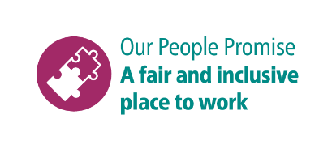

**Shortlisting questions for Apprentice Plasterer**

As part of your application, you will need to provide answers to some shortlisting questions.

Your answers to the shortlisting questions are the most important part of your application as they will be used in the shortlisting process to assess whether you meet the essential requirements for the role that are set out in the person specification and to decide whether you should be offered an interview.

Before you start your application, please read our guidance on [completing the application form](https://www.brighton-hove.gov.uk/jobs/council-jobs/application-form-guidance) and [on answering shortlisting questions](https://www.brighton-hove.gov.uk/jobs/council-jobs/shortlisting-questions-guidance) as these give important advice which will increase your chance of success in the shortlisting process.

These are the questions you will be asked for this role. Please type or paste your answers to them in the boxes that will appear as you go through the online application.

1. **What interests you about the role and attracts you to wanting to become a plasterer?**
2. **What do you hope to achieve/gain from the role?**
3. **What do you think are important qualities for an apprentice to have?**