

**Other services**

Hairdressing – we have a hairdresser in attendance on various days in the week (prices are displayed in the salon).

Chiropody – arrangements can be made for a chiropodist to visit.

Newspapers – we have a variety of newspapers delivered or clients can opt to have their own newspaper delivered.

Optician – arrangements can be made to see an optician if required.

Dentist – visits can be arranged if required.

Mobile Shop - We have a mobile shop which comes around the units to purchase toiletries, snacks and activities. We also have a small aid shop where you can purchase everyday living aids such as sock aids and leg lifters.

We have a modern gym facility with exercise equipment used to enhance physical rehabilitation.

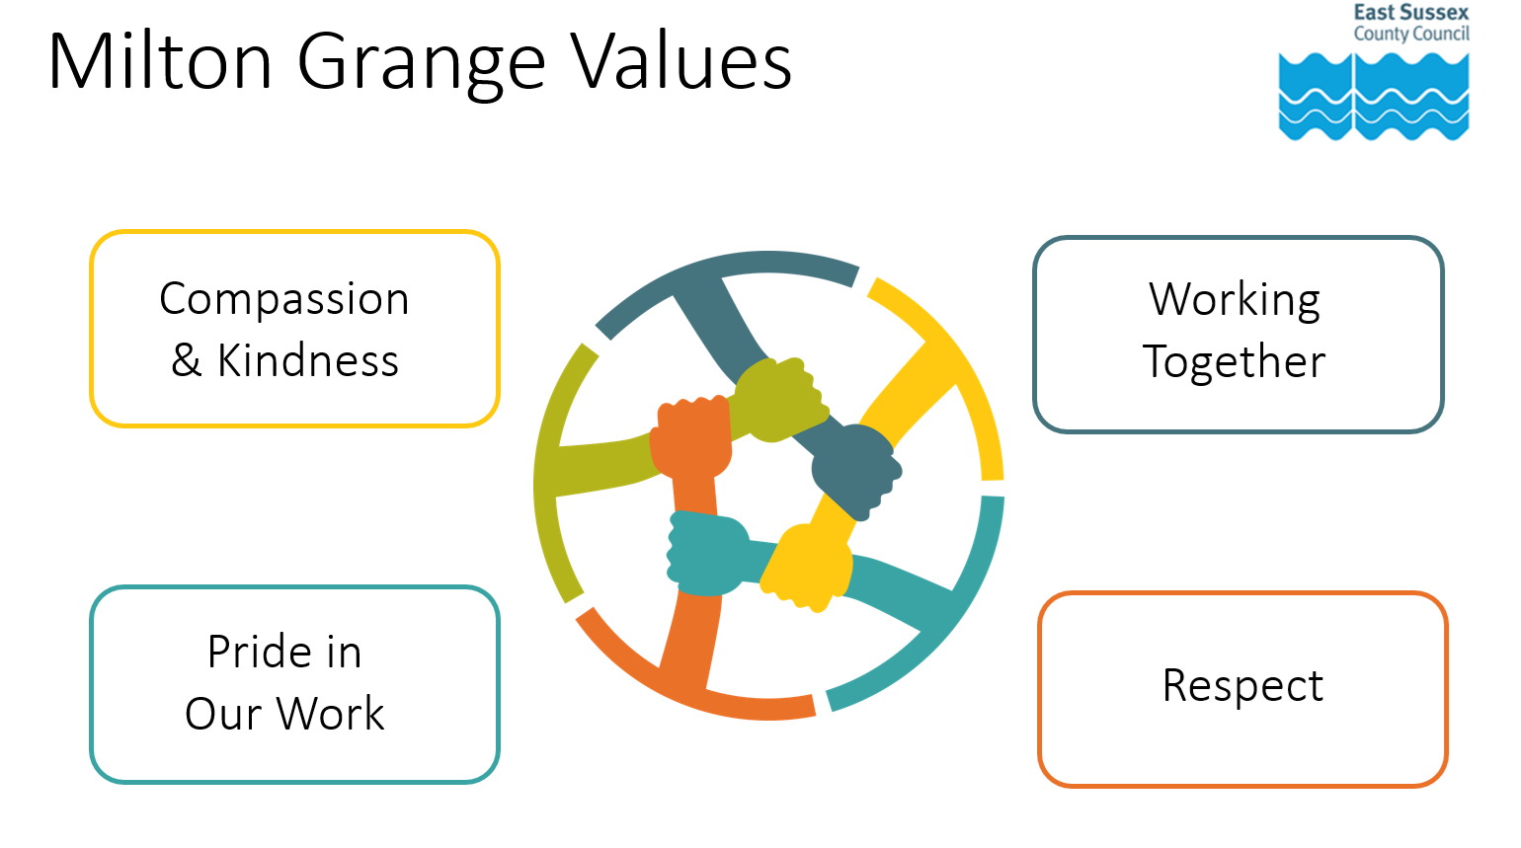

**How to find us**

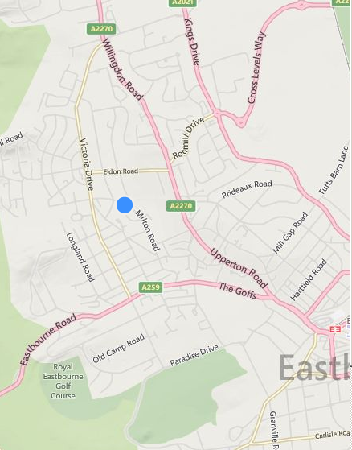 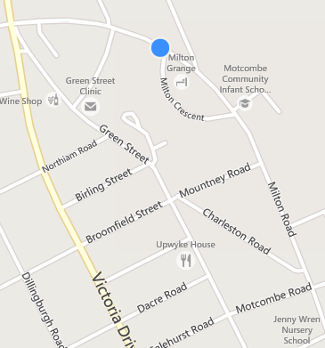

Milton Grange

Milton Road

Old Town

Eastbourne

BN21 1SL

Tel: 01323 466466

[miltongrange.referralline@escc.gov.uk](mailto:miltongrange.referralline@escc.gov.uk)

Getting more copies of this leaflet:

You can get all our leaflets in large

print, easy read format in Braille, on

audio tape or CD, or in other languages. Please phone Health and Social Care Connect 0345 60 80 191. They are also available in PDF form, which you can download from our website at eastsussex.gov.uk

March 2023

Milton Grange Intermediate Care





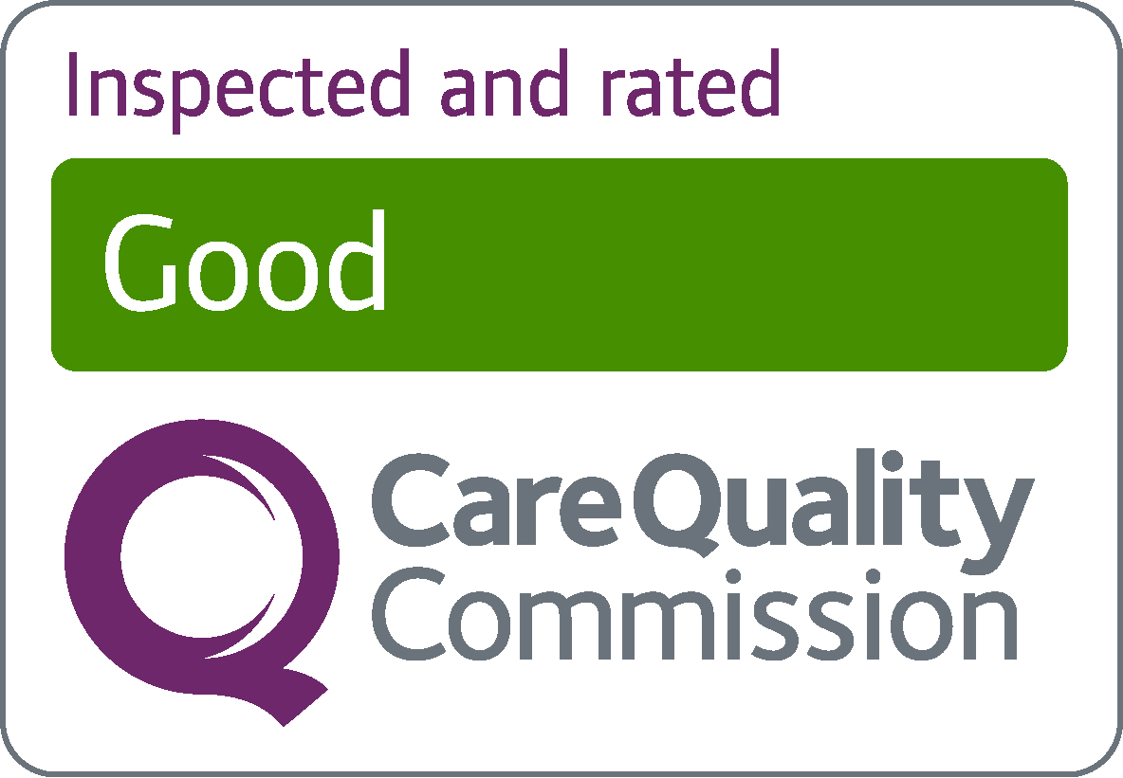

**Activities**

There are a variety of activities to take part in catering for all needs. For example, board games, quizzes, films and music appreciation as well as the opportunity to take part in chair- based exercises.

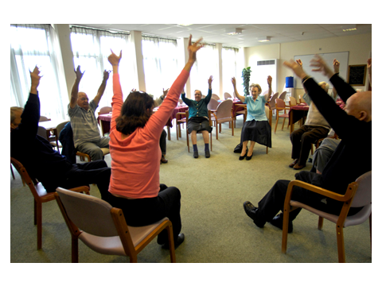

**Wi-Fi Internet**

We have a public Wi-Fi system, which means you will be able to access the internet from most areas, including your bedroom, using your own phone, laptop or tablet. Staff will be happy to assist you with accessing this.

**Meals**

All our meals are freshly prepared on site and meal choice can be selected for the following day. We can provide a selection of meals including vegetarian, diabetic, Kosher and Halal.

**Day Centre**

We have a day centre on site catering for up to 50 places in the week and 25 places at weekends.

**Accommodation**

Accommodation comprises of a fully furnished single bedroom with emergency call bells and smoke detectors. All bedrooms have an en suite shower, toilet and washbasin (there are also assisted baths available) and each room is equipped with a plasma TV.



Each unit is self-contained with its own lounge, kitchen and dining room.

We have a large garden with a decking area at the rear of the building with seating areas. There are raised planted beds and a sensory garden to enjoy when the weather allows.



**About Us**

Milton Grange is an East Sussex County Council facility regulated by The Care Quality Commission (CQC). Reports are available online at [www.cqc.org.uk](http://www.cqc.org.uk)

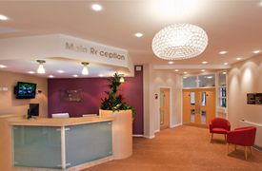

Our vision at Milton Grange is to assess, improve or restore a person’s quality of life after illness or injury through a multidisciplinary rehabilitative process. We also support our clients with mental health needs to make decisions about their care.

Staff consider all aspects of a person’s needs– Physical, psychological, social, and environmental. This support can make a real difference giving a renewed sense of purpose, opening up new horizons, which may change the way a person feels about their future.

Our team find ways to support people to manage daily tasks and activities. This might include finding support initially with self-care, accessing the community, prescribing equipment, or taking part in social and leisure activities.