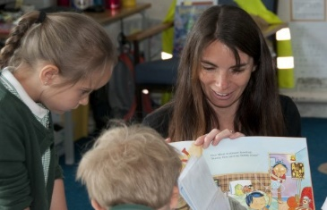

***Together we aspire, learn, achieve and thrive***

**Teaching Assistant Scale 4a**

# Salary: Contract:

**Location: Website: Email: Telephone: Required from:**

## NJC Scale 4a —£3.69 per hour £26409 pa pro rata

32.5 hours paid over 47.36 weeks/year (Monday to Friday 8.30am— 3.30pm)

County Oak Avenue, Brighton, BN1 8LU [www.carden.brighton-hove.sch.uk](http://www.carden.brighton-hove.sch.uk/) [admin@carden.brighton-hove.sch.uk](mailto:admin@carden.brighton-hove.sch.uk) 01273 916606

As soon as possible

Carden is a friendly, welcoming two form entry mainstream primary school with a nursery. The school is very inclusive and has a strong, caring ethos which is enriched by pupils from a range of social and cultural backgrounds. At Carden we also have two provisions for children with statements or EHCPs for children with Speech, Language and Communication needs from Reception to Year 6.

**We would like to appoint someone to work as an INA with children across the school**

The successful applicant will:-

* Support the pupils learning, physical, social, emotional and communication needs within the classroom and during social activities.
* Have a good knowledge and experience of the needs of children with Special Educational Needs such as ASC, Speech, Language and Communication difficulties and cognition and learning.
* Be able to work collaboratively as part of a team with professionals to maximise the pupils’ development and communication skills and deliver programmes to support the children’s needs.
* Be resilient and able to work independently, flexibly and use their own initiative to respond to the children’s needs
* Be committed to inclusion and have experience of working with children with Special Educational Needs.

We would offer you a very rewarding and enjoyable position in an exceptionally warm and friendly environment.

If you are interested in applying for this position and would like more information please contact the School Office. Visits to the school are warmly welcomed. We really look forward to hearing from you.

**Closing Date: Mid-Day 30th January 2025**

**Interviews: 5th February 2025**

***Carden Primary School is committed to safeguarding and promoting the welfare of children. The successful applicant will be required to undergo a criminal record check via the DBS if they do not already possess this document.***