West Blatchington Primary & Nursery School
Hangleton Way
Hove
BN3 8BN
Tel: 01273 770777
www.westblatchingtonprimary.co.uk
Email: head@wblatch.brighton-hove.sch.uk
Headteacher: Mr Brentnall

May 2022

Dear Candidate,

RE: ASC Facility - KS1 Teacher 1.0 FTE - Permanent: Starting 1st September 2022

Thank you for enquiring about this vacancy.

I have pleasure in enclosing an application form and further information about the internal vacancy. Please email your completed application form to admin@wblatch.brighton-hove.sch.uk.

In order to have a greater opportunity of being short-listed, please ensure that you read the important information overleaf before completing the application form.

Our school is committed to inclusion as well as the safeguarding and promoting the welfare of children and young people. The school expects all staff to share this commitment.

Please note that all appointments are subject to an enhanced DBS (Disclosure & Barring Service) check.

I look forward to receiving your application and please do not hesitate to contact us if you require any further information.

Yours Faithfully,

Carly Regan
Business Manager

IMPORTANT INFORMATION

Your application is important to us and we want to make our recruitment process as easy and fair as possible. Please take a few minutes to read the following notes and, if there is any other assistance we can provide, please do not hesitate to contact us.

- Shortlisting for interview will be based solely on the information you provide on the application form. Please include evidence of how you meet each of the criteria set out in the Person Specification. Please do not include a CV as these will be disregarded.

- Should you need to use supplementary sheets, please make sure that these are clearly marked with both your name and the post for which you are applying.

- The recruitment monitoring form, which is enclosed with the application form, is used for monitoring purposes only and is not part of the shortlisting process.

- Please ensure that we receive your application by the Closing Date shown in the advert as any late applications will be disregarded.

- If you return your application by post please ensure that you use the correct postage rate.

- All applicants shortlisted for Interview will be contacted as soon as possible. If you are not invited to Interview and would like feedback please contact us and we will arrange for the Recruiting Manager to ring you.

- We are unable to acknowledge receipt of application forms or let candidates know that they have not been selected for Interview. Therefore, if you have not heard from us within two weeks of the Closing Date, you must assume your application has been unsuccessful.

- We take the issue of safeguarding children very seriously and all applications are processed accordingly. Please note that any appointments are made subject to Enhanced DBS clearance, identity checks, continuous employment/employment gaps checks and satisfactory written references.

We have enclosed further guidance with the application form. Please read this before completing the form.

Hangleton Way, Hove, East Sussex, BN3 8BN
Tel: 01273 770777 email: admin@wblatch.brighton-hove.sch.uk

ASC Facility KS1 Teacher 1.0 FTE
We are looking for an experienced Key Stage 1 class teacher and subject leader, to work within the ASC Facility, who is committed to creating a learning culture with high expectations and achievement at its core.
Salary Grade: Teacher Main Scale / UPS + SEN1 allowance
Contract: Permanent
Start Date: 1st September 2022
Days: 1.0 FTE
West Blatchington Primary & Nursery School is an exciting, forward-looking school and a great place to work. We have a state of the art building in the middle of our local community and are looking for a KS1 class teacher for our ASC Facility. The successful applicant must have proven experience of working with pupils with complex SEN needs (in particular ASC).
They also need to be able to successfully develop a subject area whilst inspiring, engaging and enabling the pupils and people around them, to ensure that all pupils achieve the best possible outcomes.
We are a busy and dynamic school with 250 pupils and provide a warm, friendly working environment.
You will:
- Be a good or outstanding primary school practitioner.
- Have high expectations and the ability to plan an inspiring and personalised curriculum that ensures all children make good or better progress.
- Be committed to nurturing success in every child.
- Have proven experience of successfully leading a subject area across a school.
- Have the confidence and skills to enable you to effectively manage challenging behaviour.
- Demonstrate a compassionate and caring approach to working with children, parents and colleagues.

We can offer you:
- A happy, positive, vibrant working environment.
- An inclusive school with a wide and diverse community.
- Excellent opportunities for professional development.
- Talented, enthusiastic and supportive colleagues who are committed to continuous improvement.
- Focused pupils, who are eager to learn.
- An attractive and well-resourced school.

Closing date: 9am on Thursday 26th May 2022
Interview date: The morning of Friday 27th May 2022
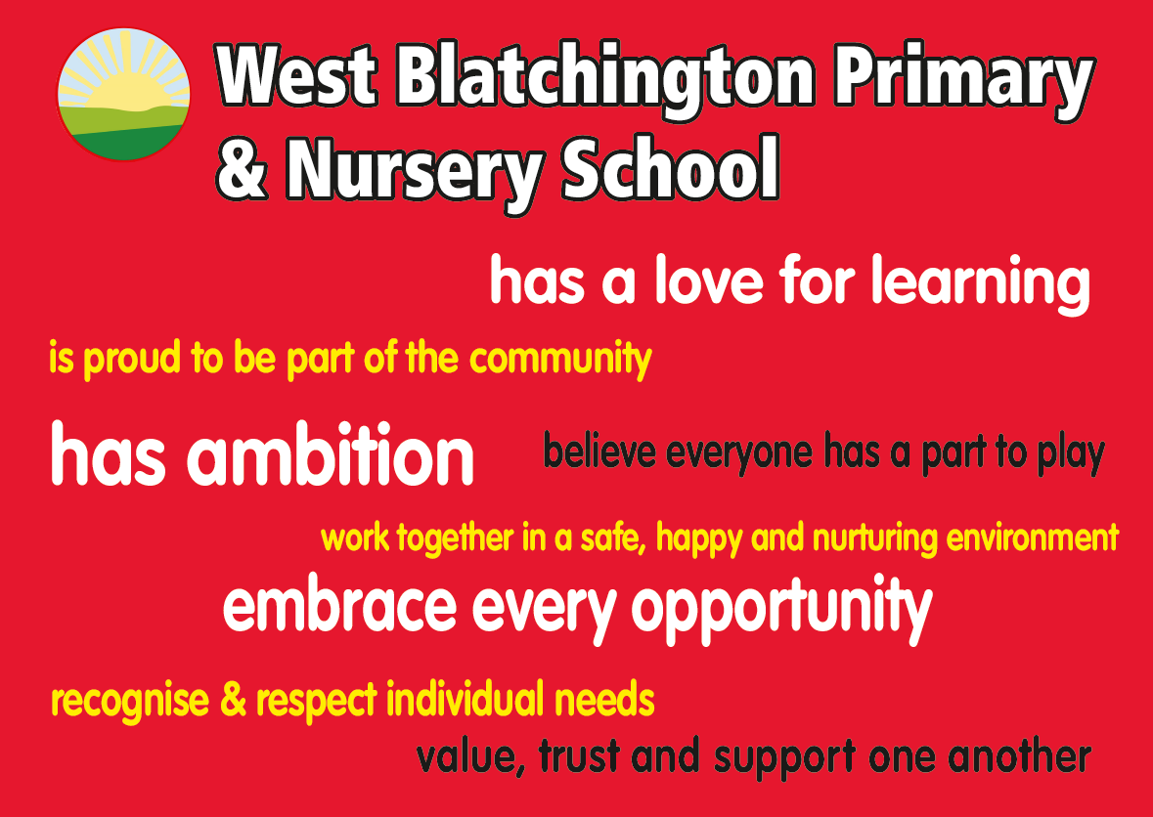
Aiming high, Nurturing all

Please phone the school on 01273 770777 to arrange visits
Completed applications forms should be emailed to admin@wblatch.brighton-hove.sch.uk.
You will have to meet the requirements of the person specification in order to be offered the post and will be subject to an enhanced DBS check. The school is committed to safeguarding and promoting the welfare of children and young people and expect all staff and volunteers to share this commitment.
JOB DESCRIPTION

JOB TITLE: | ASC Facility Key Stage 1 Class teacher
REPORTS TO: | Mel Horsfall – Teacher in Charge in the ASC Facility
SCHOOL: | West Blatchington Primary & Nursery School

_______________________________________________________________

PURPOSE OF JOB

A Key Stage 1 class teacher who can inspire, challenge and motivate all learners and who is committed to creating a learning culture with high expectations and achievement at its core.

PRINCIPAL ACCOUNTABILITIES

- Is or is working towards being an outstanding classroom practitioner who has high expectations of all children and themselves.
- Proven experience of teaching pupils with an ASC diagnosis, within the KS1 phase.
- Has the ability and determination to ensure excellent progress and raise standards.
- Is committed to bringing the curriculum alive through inspirational learning.
- Possesses excellent organisational skills and classroom management skills.
- Can work in a team and is flexible, hardworking and passionate about their work.

General

Teaching and Learning
- To plan a creative and stimulating curriculum which is differentiated to meet the range of needs within the class.
- To deliver and assess the planned curriculum.
- To develop an engaging and supportive learning environment.
- To ensure that all children learn and achieve to the best of their ability.
- To provide developmental and supportive feedback for pupils.
- To carry out formative and summative assessments of pupils and use this information to inform planning and targeted teaching.
- To be an effective role model in order to strengthen other colleagues’ practice.
- To be committed to professional development.

Pastoral Care
- To promote self-discipline, high standards of behaviour and positive attitudes on the part of all children and to implement school policies and procedures to foster them.
- To ensure that a high standard of care and good order for all children is maintained.
- To help promote and safeguard the welfare of all children.

Support for the School
- Contribute to the overall ethos of the school through embracing and promoting the school’s vision.
- Be aware of and comply with all school policies and procedures; including safeguarding, Health, and Safety, confidentiality, data protection and Whistle blowing, reporting all concerns to an appropriate person.
- Be aware of and support difference and ensure pupils have equal access to opportunities to learn and develop.
- Model professional behaviour towards staff members, pupils and their families at all times.
- Understand the importance of confidentiality and data protection, ensuring public conversations about colleagues, pupils and families are respectful and professional.
- Share the responsibility for safety, health and welfare of children and colleagues at all times, ensuring that everyone feel safe at all times, reporting all concerns to an appropriate person.
- Appreciate and support the role of other professionals.
- Attend and participate in relevant meetings as required.

The list of duties in the job description should not be regarded as exclusive or exhaustive. There will be other duties and requirements associated with your job and, in addition, as a term of your employment you may be required to undertake various other duties as may reasonably be required.

Your duties will be as set out in the above job description but please note that the Council reserves the right to update your job description, from time to time, to reflect changes in, or to, your job.

You will be consulted about any proposed changes.

Person specification – ASC Facility KS1 Teacher
A: Commitment to Vision | 1. Model and shares the school’s vision and ethos.
B: Experience | 2. Evidence of exemplary and recent Key Stage 1 classroom practice.  3. Experience of teaching pupils with a diverse range of needs, including children with a diagnosis of ASC.
C: Qualifications | 4. Qualified Teacher Status.  5. Training in relevant learning strategies.
D: Teaching & Learning | 6. Strong knowledge of the Key Stage 1 curriculum and associated assessment principles.  7. Ability to make learning engaging, relevant and challenging.  8. Commitment to developing high quality interventions.  9. Ability to plan and tailor provision across the curriculum in order to close gaps in attainment.  10. Proven track record of improving pupil progress.  11. Experience of effective subject leadership.
E: Skills | 12. Has excellent communication skills (including written, oral and presentation).  13. Can develop strong learning behaviours across the class.  14. Ability to create a happy, challenging, supportive, stimulating and effective learning environment.  15. Ability to use own initiative and work as a member of the wider school team.  16. Competent in ICT.
F: Knowledge | 17. Has a strong knowledge of the National Curriculum and the expectations of good quality primary provision.  18. Understanding of the principles of child development and learning, in the context of a child with ASC.  19. Full working knowledge of relevant polices/codes of practice and awareness of relevant legislation, including the safeguarding of children and young carers.
G: Personal Attributes | 20. Ability to relate well to pupils, staff and parents/carers.  21. Able to deal sensitively with people and achieve positive outcomes.  22. Ability to self-evaluate learning needs and actively seek learning opportunities.  23. Approachable and honest; has presence and is highly visible to pupils, parents/carers and the wider community.  24. Reliable and resilient to ensure consistent teaching and learning support to individuals, groups, and in class.  25. Ability to demonstrate flexibility in relation to assigned responsibilities.  26. Be able to work calmly in pressured situations.
H: Specifics for Role | 27. Able to provide individualised, targeted support to enable all pupils to access the curriculum.  28. Able to differentiate the curriculum to ensure all pupils can access learning.

