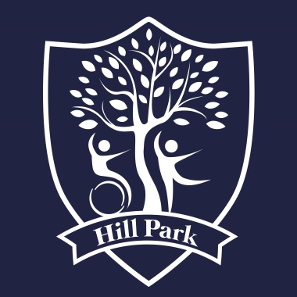
Midday Supervisor
Hill Park School
Foredown Road
Portslade by Sea
Sussex
BN41 2FU 01273 422855

Scale 1-2, Point 1-4 £18,328 - £18,933 pro rata (£9.50 to £9.81 per hour)
10 hours per week (Monday to Friday – 2 hrs per day), term time only.
Start date – asap. Fixed term contract until 31/08/2022.

Hill Park School is a 2 site special school for pupils aged 4 - 16 years with moderate (MLD), severe (SLD), profound and multiple learning difficulties (PMLD). Some pupils also have a diagnosis of autistic spectrum condition (ASC), complex medical needs, physical disabilities and / or attachment disorders.
We have students from KS1 through to KS4 and we will place suitable candidates across the school depending on their experience and skills.
This role could be based in the school hall where the children eat, in the classroom or in the playground and will include:
- Encouraging good manners and assisting children with their food where necessary
- Interacting with the children in outdoor play
- Supervising children in classrooms on wet days
- Working 1-1 with specific children when required to
- Enjoy working with children
- Be able to manage a challenging environment, both physically and mentally

The role may require intimate and personal care but full training will be provided.
We take safeguarding and child protection seriously and all posts at Hill Park are subject to a satisfactory Enhanced Disclosure and Barring Certificate.
Please return the completed application form by email to: vacanciesupper@hillpark.brighton-hove.sch.uk

Application Deadline: 9am Friday 5th November 2021
Interview Date: Friday 12th November 2021

