sdggdgdfgfdgd  Access to the service:  - The service is available to adults who are registered with a GP in East Sussex.  - The service is designed for older adults with an identified low complexity mental health need which is impacting on daily life, and for which assessment and/or intervention is considered likely to be beneficial.  - Where the need is impacting on the persons physical/emotional/cognitive or social wellbeing.  - Where the need is impacting on the carers ability to continue to provide care.  - The person must be medically stable (or being actively treated for diagnosed condition) and have been assessed by the referrer (or team member) within the previous 72hrs.  Referral Process:  - Referrals are made via ESCC single point access HSCC esh-tr.hscc@nhs.net 0300 6780 010 (Professional line) or HSCC@eastsussex.gov.uk 0345 60 80 191 (Public line)  - Referrals can be made by primary care teams (GP’s, Community nurses).  - Community and acute hospital social work teams  - CMHT, JCR, and Carers Breaks Service.  - An informal discussion with the team prior to referral may be useful | Contact Details  Milton Grange  Milton Road  Old Town  Eastbourne  BN21 1SL  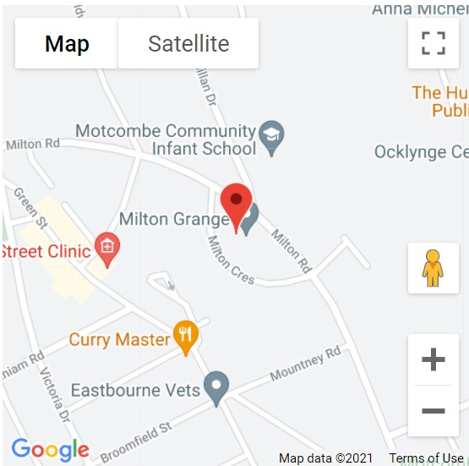  01323 464345 | Milton Grange  Mental Health Community  Outreach Service

Hours
The service operates between
8:00am-16:00pm, seven days a week and has the capacity to support up to 15 clients at a time. It is a short-term service offered for a maximum of 4 weeks. Services are provided at community locations including care homes and the person’s home. The Mental Health Community Outreach service is part of the Milton Grange suite of Intermediate Care services and is a countywide service.

Who are we and what do we do?
As part of Adult Social care, the Milton Grange Mental Health Community Outreach service provides assessments and rehabilitation services to support people in the community to promote independence, to enable people to remain in their own homes, prevent admission to hospital or facilitate discharge from hospital. The service offers support to people with functional mental health needs and mild to moderate cognitive impairments.

The Team  The Outreach service has a multidisciplinary team comprising of an Outreach Service Manager, Deputy Manager, Occupational Therapists, Physiotherapists, Therapy Assistants and Specialist Mental Health Nurses. | Our main aims are:  Promote faster recovery from illness  Prevent unnecessary hospital or care home admission  Support timely discharge from hospital  Maximise independent living at home and in the community  Enable users to remain, or resume, living at home  Support Carers thus avoiding carer breakdown  Identify care and support needs through assessment  To facilitate client engagement with community activities | We can offer:  Mental Health Assessments and individual support plans.  Therapy to enable people to regain independence.  Information and advice for those seeking care and support.  Support which reduces the need for social care in the longer term or reduces the need for more expensive forms of care.  Help to identify everyday tasks you can do which you may find difficult.  Ways to develop and practise everyday skills  Support and advice for carers.

