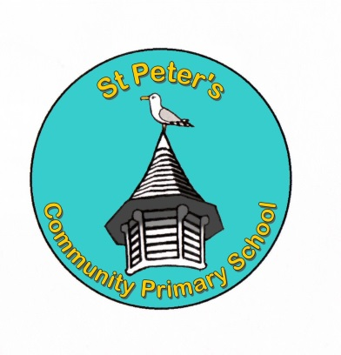

Dear Candidate

Re: Year 6 Permanent Teacher Post

Thank you for your interest in our vacancy. Please read the accompanying documents for further information about the post.

At St. Peter’s we have a strong, family–orientated ethos and believe in providing an inspiring and supportive learning environment to engage and motivate our children. We are a one form-entry primary school with a vibrant, enquiry based approach to the curriculum. We work closely with multi-agency services and are committed to parent partnership and community involvement.

Please have a look at our website to find out more about us: www.stpeters.brighton-hove.sch.uk.

We ask all candidates to ensure that the supporting statement of their application form is written with subheadings corresponding to each of the criteria identified in the person specification for this role. Applications not following this layout will not be considered.
We welcome applications from all parts of our community as we aspire to have a staff body that matches the social and cultural diversity of our families.
St. Peter’s Community Primary School is committed to safeguarding and promoting the welfare of children and young people and expects all staff to share this commitment.

Please apply by e-mailing your application to: office@stpeters.brighton-hove.sch.uk or by posting your application to our address.

The closing date is Friday 3th December 2021 at midnight. We look forward to receiving your application.

Yours sincerely

Mrs Michele Lawrie
Head Teacher

