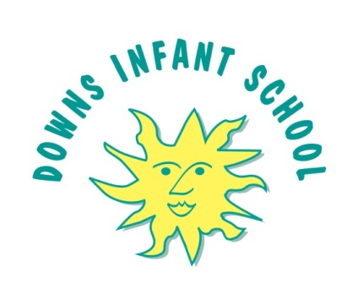

Teaching Assistant Level B within the SEN Team
Salary: £19,650 - £20,043 pro rata
Start Date: September 2022
Hours per week: 25 hours per week, permanent
Closing date for applications: Monday 13 June 2022
Interviews: Tuesday 21 June 2022

Downs Infants is a warm, open and nurturing school, which has a deep commitment to a child-centred and unique infant education. We have a strong sense of community, which is inclusive of all, and teach our children to be kind and foster a love of learning.

We take a creative and innovative approach to education here, fostering an inquisitive and curious approach to the curriculum where we value the role of play for infant children. Our SEN team work flexibly to support our children with SEN, sometimes providing individual support and sometimes working with a small group, or supporting in class. Alongside a knowledge of and passion for working with children with SEND, a knowledge of both EYFS and Key Stage 1 is essential for this post because we use continuous provision alongside direct teaching throughout our school.
Further information can be obtained from the School Office or by e-mail annmitchell@downsinf.brighton-hove.sch.uk
Please note that this post is exempt from the Rehabilitation of Offenders Act 1974, and is subject to a Disclosure & Barring Service (DBS) Check.
Downs Infant School is committed to safeguarding and promoting the welfare of children and young people and expects all staff and volunteers to share this commitment. We are committed to promoting equality and challenging inequality and stereotypes and are on a journey to becoming an anti-racist school.

