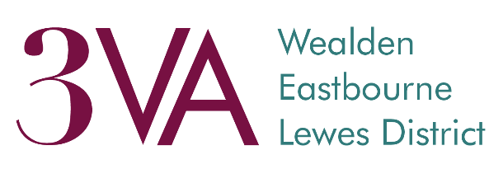

Equal Opportunity Monitoring Information

Personal information including gender, ethnicity and age is collected by 3VA is for monitoring purposes only and will not be used in any decisions affecting you.

This page is an optional part of our Registration form that will help us further analyse your responses based on the demographic data you provide us with. The responses that you do give will assist us greatly in our commitment to diversity and will be kept strictly confidential.

- Gender: which of the following best describes your gender?
Male | Female | Prefer not to say | Prefer to self‐describe
Option to self‐describe: | Click here to enter text.
- Sexual orientation: which of the following best describes your sexual orientation?
Bi | Gay or Lesbian | Heterosexual/Straight | Prefer not to say | Prefer to self‐  describe
Option to self‐describe: |  | Click here to enter text.

- Gender Identity: are you trans or non-binary?
Yes | No | Prefer not to say | Prefer your own term
Option to self‐describe: | Click here to enter text.
- Disability: do you consider yourself to be disabled?
Yes | No | Prefer not to say
Under the Disability Discrimination Act, a disability is defined as ‘a physical or mental impairment that has a substantial and long-term adverse impact on the ability to carry out normal day-to-day activities’

5. Ethnicity: what is your ethnic group? | 6. | Religion and belief: what is your religion?
Arab  Asian or Asian British: Indian Asian or Asian British: Pakistani Asian or Asian British: Bangladeshi Asian or Asian British: Chinese Asian or Asian British: Other  Black or Black British: African Black or Black British: Caribbean Black or Black British: Other Mixed: White and Black Caribbean |  | Buddhist Christian Hindu Jewish Muslim  Non‐religious (atheist, Humanist etc.) Sikh  Other  Prefer not to say Prefer to self‐describe
Mixed: White and Black African Mixed: White and Asian
Mixed: Other White: British White: Irish
White: Other
If any other ethnic group or you prefer your own defi  Prefer not to say |  | nition please specify:

7. Age:
16‐24 | 25‐34 | 35‐44 | 45‐54 | 55‐64 | 65+ | Prefer not to say
1

