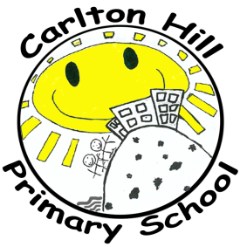
POST DETAILS PACK

The Governors of Carlton Hill Primary School
are looking to appoint a

Class Teacher for Upper KS2
(Permanent Full-Time post)
Teachers Main Scale / Upper Pay Scale

The successful candidate will have:
- Qualified Teacher status
- A strong commitment to working in partnership with pupils, staff, parents and the community, in a culturally diverse setting
- Excellent teaching skills and high expectations of all pupils’ achievement
- The motivation and creativity to deliver a rich and rounded curriculum
- A commitment to inclusion of all pupils
- Positive behaviour management skills
- Excellent interpersonal and communication skills
- Enthusiasm, positive energy and a good sense of humour
- A good understanding of the Upper KS2 phase

In return the successful candidate will receive:
- A warm welcome from a professional, highly skilled staff team
- Effective tailored induction with ongoing professional development
- Support from a forward thinking and motivated Senior Leadership Team
- Experience of teaching in a vibrant, multicultural, inner-city school
- Job satisfaction from working with enthusiastic and engaging children
- Strength from being part of a thriving Partnership of schools

Carlton Hill Primary School is part of the Brighton City Partnership for Education (BCPfE) and also the South Coast Teaching School Alliance (SCTSA) who work in close collaboration to improve teaching and learning in our schools.

Carlton Hill Primary School is committed to safeguarding and promoting the welfare of children and young people and expects all staff and volunteers to share this commitment. Please note that this post is exempt from the Rehabilitation of Offenders Act 1974 and is subject to an Enhanced Disclosure and Barring Service check.

Brighton & Hove Schools - Taking Action for Equality

Advert date: Fri 20th March 2020
Closing date for applications: Midnight Monday 20th April 2020
Candidates invited to interview: Wed 22nd April 2020
Interviews: Monday 27th April and Tuesday 28th April 2020
Start date: 1st September 2020

Further details and application forms are available from the school: admin@carltonhill.brighton-hove.sch.uk or tel: 01273-604966. Applications can be submitted online through the Council’s recruitment system, or sent directly to the school office by e-mail.

Visits are strongly encouraged. Please let the school office know if you would like to visit: 01273–604966.

There are five opportunities for this on:

Tuesday 24th March 11am-12noon
Thursday 26th March 3.30 – 4.30pm
Friday 27th March 9.45 – 10.45am
Tuesday 31st March 9.30-10.30
Thursday 2nd April 3.45-4.45pm

If you are unable to visit then you are welcome to ring the Headteacher for a conversation.

