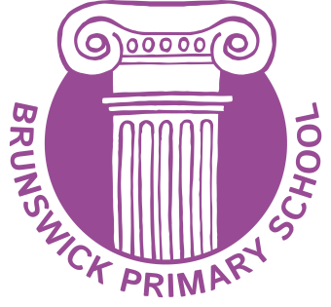

Clerk to Governors

School: Brunswick Primary School
Hours: 4 hours per week, term time only plus extra hours for clerking working groups and panels
Contract type: Permanent
Start date: 1st September 2022
Salary band: Scale 3, £19,650 - £20,043 or Scale 5, £22,571 - £24,920 per annum, pro rata (depending on experience)

We are looking for a Clerk who will provide high level advice, support and administrative assistance to our governing body. This involves arranging meetings, taking minutes, keeping records and advising the governing body on local and national developments that will impact on their work.

You must have experience of minute-taking, good ICT and communication skills and be able to work with minimal supervision. Training for clerks is provided by the local authority, as well as opportunities to network with other Clerks.

We are ideally looking for an experienced professional who can be employed at the Senior Clerk level (Scale 5). However, we are also able to provide development opportunities for those who wish to work towards this level, so can offer the role at Scale 3 in the first instance. The local authority offers a 12 month Clerks’ Development Programme, which you would be expected to complete before moving to the next level.

Flexibility in terms of working hours is required with our board and committee meetings scheduled before and after school teaching hours. Senior Clerks are also required to clerk working groups and panels as required, for which you will be paid extra hours.

For further information please contact:

Chair of Governors, Claire Roberts – claireroberts@brunswick.brighton-hove.sch.uk
Headteacher, Susan Thompson – head@brunswick.brighton-hove.sch.uk
School Office – 01273 711816

To request an application pack please email recruitment@brunswick.brighton-hove.sch.uk

You may also download an application pack from our school website, clicking on the ‘Vacancies’ tab at: http://www.brunswick.brighton-hove.sch.uk

Closing Date: 12 noon on Friday 8th July 2022
Shortlisting: Friday 8th July 2022
Interview Date: Week beginning 11th July 2022

Brunswick Primary is committed to safeguarding and promoting the welfare of children and young people and expect all staff and volunteers to share this commitment.

