November 2021

Dear Candidate,

Re: School Business Manager

Thank you for contacting us about this vacancy.

I have pleasure in sending you an application form and further information about it.

Please read the important information enclosed before completing the application form.

Visits to the school are recommended. Please contact the school office to make an appointment.

I look forward to receiving your application.

Yours sincerely,

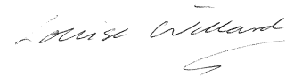

Ms Louise Willard
Headteacher

