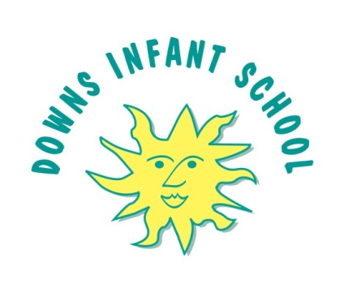

Teaching Assistant Level B – 17.5 hours per week
Salary : £19,650 - £20,043 pro rata
Start Date: September 2022
Hours per week: Mornings, permanent (17.5 hours)
Closing date for applications: Monday 13 June
Interviews: Tuesday 21 June

Downs Infants is a warm, open and nurturing school, which has a deep commitment to a child-centred and unique infant education. We have a strong sense of community, which is inclusive of all, and teach our children to be kind and foster a love of learning.

We take a creative and innovative approach to education here, fostering an inquisitive and curious approach to the curriculum where we value the role of play for infant children. By providing evidence-based and deliberately planned environments alongside a carefully sequenced curriculum we are able to give children opportunities to deepen and apply their knowledge and ensure access to a broad and balanced curriculum for all pupils. A knowledge of both EYFS and Key Stage 1 is essential for this post because we use continuous provision alongside direct teaching throughout our school.
Further information can be obtained from the School Office or by e-mail annmitchell@downsinf.brighton-hove.sch.uk
Please note that this post is exempt from the Rehabilitation of Offenders Act 1974, and is subject to a Disclosure & Barring Service (DBS) Check.
Downs Infant School is committed to safeguarding and promoting the welfare of children and young people and expects all staff and volunteers to share this commitment. We are committed to promoting equality and challenging inequality and stereotypes and are on a journey to becoming an anti-racist school.

