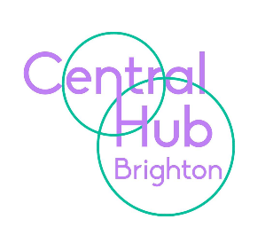

Central Hub Brighton

Vacancy for Level B INA, Homewood College
Fixed term until July 2022
Working hours: 32.5hrs

Central Hub Brighton needs a dynamic and innovative Individual Needs Assistant to join our team. You will have to have the resilience and ability to work as part of a small team dedicated to supporting our young people with SEMH to help overcome their barriers to learning and instil the skills that they need to succeed.

You will need to be:

- Flexible and able to travel across sites
- Supportive to learners
- Adaptable to changing classroom climates
- Able to effectively manage challenging behaviour

Central Hub Brighton currently has four sites over the City, the PRU element at Lynchet Close and Dyke Road, KS4 Hub and Homewood College. We have good links with other educational organisations in the city and share resources and training opportunities. We have an enthusiastic staff team and strive always to ensure our learners have access to the best possible educational experience in order that our students can overcome any barriers they have had to learning in the past. Central Hub Brighton is committed to safeguarding and promoting the welfare of children and young people and to equality of opportunity. We expect all staff and volunteers to share this commitment. Please note that this post is exempt from the Rehabilitation of Offenders Act 1974, and is subject to a Disclosure & Barring Service (DBS) Check Central Hub Brighton is committed to the principles of equality and to carry out duties in accordance with the Council’s Inclusive Council Policy.

Please note we do not accept CVs. Applications should be made using the application form attached, alternatively contact Siobhanjustice@chb.org.uk for a copy.

For any other details or to arrange a site visit, please contact Brian Hoten on 01273 916595 or email brianhoten@chb.org.uk. Please also see our website www.chb.org.uk

Deadline for applications: 05.11.2021
Interview Date: TBC

