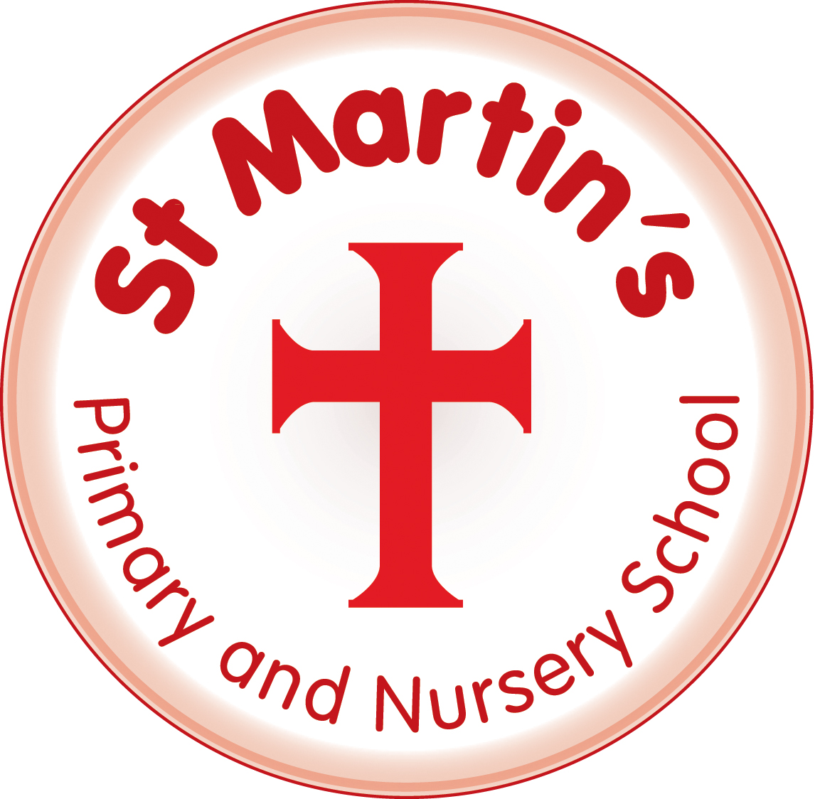
St Martin’s CE Primary and Nursery School

JOB DESCRIPTION

Job Title: Mid-day Supervisory Assistant (M.S.A)

Reports to: Senior Mid-day Supervisory Assistant/Deputy Head/Head Teacher

Department: Children, Schools and Families

Section: Schools

Purpose of the Job

To be responsible for the supervision and to ensure the safety of pupils in all areas inside or outside the school building throughout the midday break.

Principal Accountabilities

- To supervise children at lunch time and to ensure their safety.
- To actively promote positive behaviour in the playground by ensuring the zoned areas are utilised properly and intervening to encourage positive play activities.
- To deal with inappropriate behaviour in accordance with the behaviour policy procedures and where necessary to report difficulties to the line manager.
- To help solve conflict amongst children.
- To mop up and wipe spillage from floor surfaces or meal tables as and when necessary.
- To ensure that dining areas are left in a tidy condition.
- To attend to injured or sick children, including clearing up in accordance with the school’s first aid procedures.
- To ensure that any injury or sickness of children are referred for First Aid treatment.
- To check that pupils do not remain in outside areas where lesson afternoons are due to begin.
- To ensure that all playground equipment is used in a safe and appropriate manner.
- To encourage positive game playing and sharing.
- To supervise children utilising toilet facilities.
- To have knowledge of individual pupils special needs and requirements.
- To access all equipment and make it available to Children and pack such equipment away.

- To uphold the School’s policies for anti-discriminatory practice and equality of opportunity.

- To uphold the School’s and other departments’ Health and Safety requirements, particularly with regard to agreed codes of practice and safe methods of working.

Your duties will be as set out in the above job description but please note that the School reserves the right to update your job description, from time to time, to reflect changes in, or to, your job.

You will be consulted about any proposed changes.
The list of duties in the job description should not be regarded as exclusive or exhaustive.

There will be other duties and requirements associated with your job and, in addition, as a term of your employment you may be required to undertake various other duties as may reasonably be required.

BRIGHTON & HOVE CITY COUNCIL

PERSON SPECIFICATION

Post Title: Mid-day Supervisory Assistant (MSA)

Department: Children, Families and Schools

Section: Schools

Criteria | Essential Criteria
Job Related Knowledge, Experience and Qualifications | - Experience of working with children outside of the home (minimum of one year preferred)  - Knowledge of the school’s first aid procedures
Skills and Abilities | - Ability to work to time constraints  - Ability to use own initiative  - Ability to support colleagues and contribute positively to team building and working together  - Ability to listen and to communicate effectively with children  - Ability to respond and act quickly to varying situations in a calm manner
Other Requirements | Personal Qualities  - Committed  - Good Interpersonal skills  - Patient/Calm  - Firm but fair attitude  - Flexible

