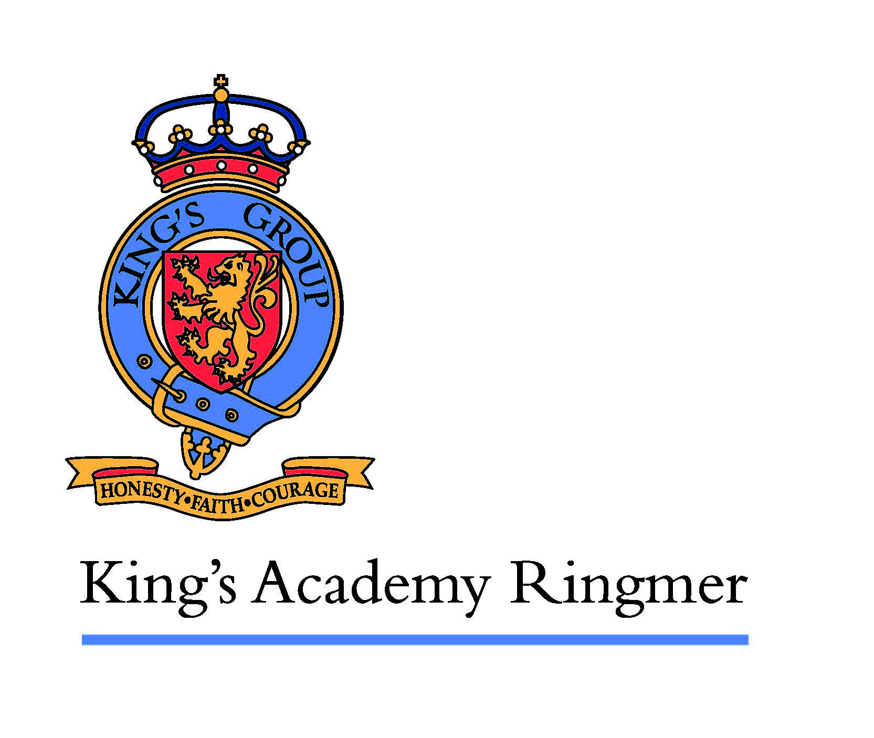

KING’S ACADEMY RINGMER

MARKETING, ADMISSIONS AND TRANSITION MANAGER

37 hours per week. Required to start asap
Permanent, TTO + 1 additional week to be worked during the summer closure

Salary – KGA Pay Scale, Band 6, Points 9 to 13
Ie: £27363pa to £31067pa to be pro-rated

We are seeking a dynamic, enthusiastic and motivational individual to undertake the roles and responsibilities of this unique and rarely available position. We are seeking a colleague who will be the face and point of contact at King’s Academy Ringmer in the community, proactively developing the school’s public profile and reputation both in person and through digital marketing communication. This role presents an exciting opportunity for someone to bring their vision to further develop our thriving school community.

The successful applicant will also be responsible for the student recruitment cycle from primary feeder schools as well as in year admissions. You will lead on all aspects of marketing and admissions to meet the schools’ objectives, making sure all functions are performed in a timely, efficient, and effective manner, as well as leading on marketing campaigns, open days and events.

This role is term-time only plus one additional week to be worked during the summer closure.

King's Academy Ringmer is a rural comprehensive with values of kindness, ambition and resilience. We have a strong reputation for our inclusion, pastoral care and a rapidly improving trend of results in terms of student attainment and progress. The Academy is part of King's Group Academies whose mission is to equip all students with the confidence, knowledge, skills and values that will enable them to thrive in the modern world. We anticipate exciting developments ahead working together with students, parents/carers and the wider community to build upon our strengths and make this an outstanding school.

What can we offer you?
• A chance to be at the forefront of educational development.
• An Academy with a positive ethos, motivated students and focus upon learning
• Excellent induction, support and staff development opportunities
• A beautiful, rural environment situated approximately 12 miles from the coastal city of Brighton and Hove

For full details and an application form can be download directly from our website: https://www.kgaringmer.uk/vacancies/support-staff-vacancies or contact Amanda French on either 01273 815460 or amanda.french@kingsacademies.uk quoting job reference P/489. We offer a first class working environment with supportive colleagues and opportunities for career development.

King’s Academy Ringmer is committed to safeguarding and promoting the welfare of children and young people and expects all staff and volunteers to share this commitment. All posts within our Multi Academy trust are exempt for the Rehabilitation of Offenders Act 1974 and therefore all applicants will be required to declare spent and unspent convictions, cautions and bind-overs, including those regarded as spent and complete an Enhanced Criminal Records Disclosure via the Disclosure and Barring Service (DBS)

Closing date for applications is Friday 3 January 2025 at 8.30am with the interview date on Tuesday 7 January 2025.

We advise applying promptly for this post as we reserve the right to close and interview early if sufficient suitable applications have been received.

